

**QUIZ APPLICATION**

A Minor Project Report submitted at Medi-Caps University, Indore

in partial fulfilment of the degree of

**Bachelor of Computer Applications**

**Submitted by:**

PRADHYUMN SINGH GINNARE (SC20CS301042)

MANAV RATHORE (SC20CS301034)

ANKUSH JOSHI (SC20CS301017)

**Department of Science**

**Medi-Caps University, Indore- 453 331**

**Aug-Dec 2022**

|  |  |
| --- | --- |
|  | **Medi-Caps University**  **A. B. Road, Pigdamber, Rau, Indore-453 331** |

**CERTIFICATE**

This is to certify that

Mr. PRADHYUMN SINGH GINNARE [SC20CS301042]

Mr. MANAV RATHORE [SC20CS301034]

Mr. ANKUSH JOSHI [SC20CS301017]

have completed their minor project entitled **‘Quiz Application’**. The project work is the requirement of Fifth (Odd) Semester of the degree of Bachelor of Computer Applications (BCA).

Signature:…………. Signature:………….

Name: Ms. Barkha Namdev Name: Dr. Jitendra Choudhary

**(Project Guide)** **(Head of Department)**

The report has been examined and valued by us.

Signature:…………. Signature:………….

Name:……………... Name:……………...

**(Internal Examiner) (External Examiner)**

**Date: Date:**

**ACKNOWLEGMENT**

The satisfaction accompanies that the successful completion of any task would be incomplete without the mention of people whose cooperation made it possible, whose constant guidance and encouragement crown all efforts with success.

We are grateful to our project guide **Ms. Barkha Namdev** for the guidance and constructive suggest that helps us to in the preparation of this minor project.

**Quiz Application**

**Content:**

1. **Introduction**
   1. Aim
   2. Objective
   3. Purpose
   4. Scope
   5. Applicability
   6. Description
2. **System Requirement Analysis**
   1. Problem Definition
   2. Hardware Requirement
   3. Software Requirement
   4. Technology Used
3. **Diagrams**
   1. Waterfall Model
   2. ER Diagram
   3. UML Diagram
      1. Use Case Diagram
      2. Data Flow Diagram
      3. Class Diagram
4. **Testing**
   1. White Box Testing
   2. Black Box Testing
   3. Unit Testing
   4. Integrated Testing
   5. Beta Testing
5. **Screenshots**
6. **Conclusion**
7. **Reference**
8. **Introduction**

The project: "Quiz Application' is a collection of number of different types of quizzes like technical, games, sports, etc. A user can access/play the entire quiz and can attempt any of the one. There will be limited number of questions and for each correct answer user will get a credit score. User can see answers as well as can ask a query related to it. There are many quiz applications available currently on internet. But there are few which provide better understanding between users and the application like, providing proper answers, user query Solving, uploading user questions as well as answer to it, etc. To develop a user-friendly quiz application which will contain: Numbers of quiz. Answers to every question, Query solving regarding any question, Uploading of user question and answer, and to improve the knowledge level of users. To develop an application which will contain solution to the above problems. By this application the user will come to know about his/her level and can learn additional knowledge. Also by this application a user can expand his/her knowledge among the world.

* 1. **Aim:**

Our aim is to develop an application for the users in which a user can attempt any number of quizzes related to his/her choice.

* 1. **Objective:**

The main objective of "Quiz Application is to facilitate a user-friendly environment for all users and reduces the manual effort. In past days quiz is conducted manually but in further resolution of the technology we ae able to generate the score and pose the queries automatically. The functional requirements include creating users that are going to participate in the quiz, automatic score and report generation and administrative tasks like add, delete. update for admin privilege users. In this application. all the permissions lies with the administrator i.e. specifying the details of the quiz with checking result will show to interviewee or not. addition of question and answers. marks for each question. Set timer for each quiz and generate report with score for each quiz.

* 1. **Purpose:**

This web application provides facility to Play online quiz and practice Grammar, Aptitude, and G.K. It provides a good platform, where a student not only judges there knowledge/skill but also they can improve knowledge/skill at the same time.

* 1. **Scope:**

The Scope of this project is very broad in terms of gaining knowledge and sharing knowledge among world.

Few points are:

* Can be used anywhere any time as it is a web-based application
* This application will be used in educational institutions as well as in corporate world.
  1. **Applicability:**

Anyone. whether a newcomer or professional, willing to learn they can choose it All users will have access to all subject containing sub topics, users will receive best experience without any interruptions.

* 1. **Description:**

Firstly, we have to make interfaces for Home Page Login Page, Questions Attempting forum, Result Page, & Profile of user. Currently, there are websites which only provide limited number of quizzes related to different domain. Many websites do not have a single platform for quizzes related to technical, G.K Aptitude. Games. etc. And there is not a website where the users can upload his/her questions and answers to the others. We have to develop an application which can resolve all of the above problems. By this user can gain knowledge, can solve his/her query and spread his/her knowledge among the World.

1. **System Requirement Analysis**

**2.1 Problem Definition:**

Quiz Contest is an application developed to conduct a quiz based on time constraints. Quiz Contest system is accessed by entering the username. Before start of the quiz, the rules and regulations are displayed that includes description of the time limit, number of questions to be answered and scoring methods. Quiz is started by displaying one question with four options each based on computer and general knowledge. if the answer is correct, 10 score is incremented and no negative marks for wrong answers. If the time exceeds 15secs next question will come automatically after giving few limited question's answer quiz application will finally direct you to the score page. Final score will be displayed.

* 1. **Hardware Requirement:**

Most current Computers and Laptop have enough specifications to be used to create an Application. The most important specification to check on the computer would be the size of the RAM, which should be over 2 GB, more is better. This will ensure that the computer runs quickly and smoothly, even with heavier programs. The computer should have a keyboard and mouse attached and working as well.

|  |  |  |
| --- | --- | --- |
| **S.NO** | **NAME** | **HARDWARE** |
| 1. | Processor | Intel dual core (32 bit) |
| 2. | RAM | 2 GB |
| 3. | Processor Speed | 1. GHz |

* 1. **Software Requirement:**

Aside from a Computer and internet connection, most of the tools you need to build an Application are Software Program. Some of which may already be on your computer.

|  |  |  |
| --- | --- | --- |
| **S.NO** | **NAME** | **SOFTWARE** |
| 1. | Platform | Windows 10 |
| 2. | Language Used | Java |

**2.4 Technology Used:**

* **Java:**

Java is an object-oriented programming language that produces software for multiple platforms. When a programmer writes a Java application, the compiled code (known as bytecode) runs on most operating systems (OS), including Windows, Linux and Mac OS.

* **Java Swing:**

Swing is a GUI widget toolkit for Java. It is part of Oracle’s Java Foundation Classes – an API for providing a graphical user interface for Java programs. Swing was developed to provide a more sophisticated set of GUI components than the earlier Abstract Window Toolkit.

* **Java AWT:**

The Abstract Window Toolkit (AWT) is Java's original platform-dependent windowing, graphics, and user-interface widget toolkit, preceding Swing. The AWT is part of the Java Foundation Classes (JFC) — the standard API for providing a graphical user interface (GUI) for a Java program.

1. **Diagrams**

**3.1 Waterfall Model**

The Waterfall Model was the first Process Model to be introduced. It is also referred to as a **linear-sequential life cycle model**. It is very simple to understand and use. In a waterfall model, each phase must be completed before the next phase can begin and there is no overlapping in the phases.

The Waterfall model is the earliest SDLC approach that was used for software development.

The waterfall Model illustrates the software development process in a linear sequential flow. This means that any phase in the development process begins only if the previous phase is complete. In this waterfall model, the phases do not overlap.

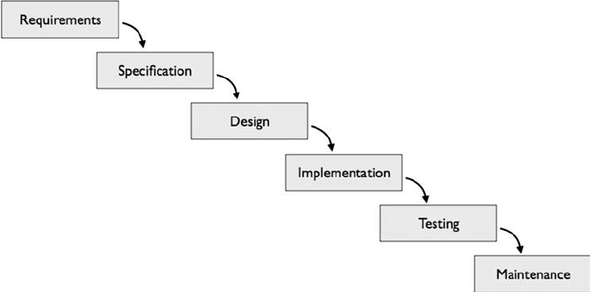

**Fig:** Waterfall Model

* 1. **ER Diagram**

An entity relationship diagram (ERD), also known as an entity relationship model, is a graphical representation that depicts relationships among people, objects, places, concepts or events within an information technology (IT) system.

Rules

Student

Score

Quiz

**Fig:** ER Diagram

* 1. **UML Diagrams**

A UML diagram is a diagram based on the UML (Unified Modeling Language) with the purpose of visually representing a system along with its main actors, roles, actions, artifacts or classes, in order to better understand, alter, maintain, or document information about the system.

* + 1. **Use Case Diagram**

Use-case diagrams describe the high-level functions and scope of a system. These diagrams also identify the interactions between the system and its actors. The use cases and actors in use-case diagrams describe what the system does and how the actors use it, but not how the system operates internally.

Admin

User

**Fig:** Use Case Diagram

* + 1. **Data Flow Diagram**

A Data Flow Diagram (DFD) is a traditional visual representation of the information flows within a system. A neat and clear DFD can depict the right amount of the system requirement graphically. It can be manual, automated, or a combination of both.

It shows how data enters and leaves the system, what changes the information, and where data is stored.

The objective of a DFD is to show the scope and boundaries of a system as a whole. It may be used as a communication tool between a system analyst and any person who plays a part in the order that acts as a starting point for redesigning a system. The DFD is also called as a data flow graph or bubble chart.

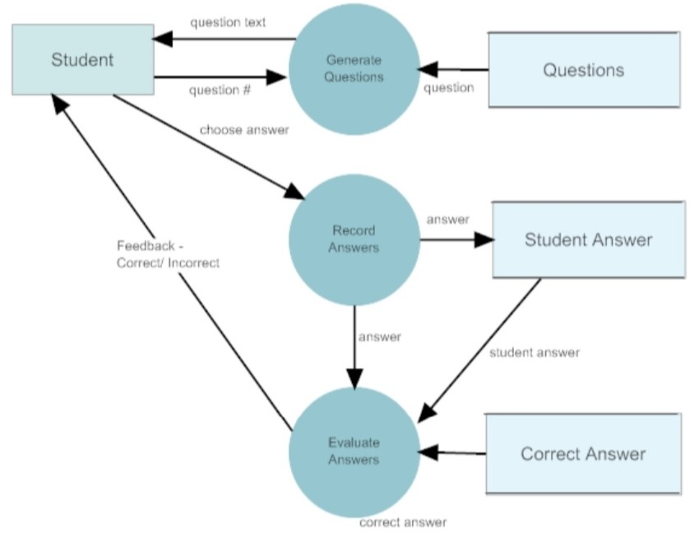

**Fig:** Data Flow Diagram

* + 1. **Class Diagram**

Class diagram is a static diagram. It represents the static view of an application. Class diagram is not only used for visualizing, describing, and documenting different aspects of a system but also for constructing executable code of the software application.

Class diagram describes the attributes and operations of a class and also the constraints imposed on the system. The class diagrams are widely used in the modelling of object-oriented systems because they are the only UML diagrams, which can be mapped directly with object-oriented languages.

Class diagram shows a collection of classes, interfaces, associations, collaborations, and constraints. It is also known as a structural diagram.

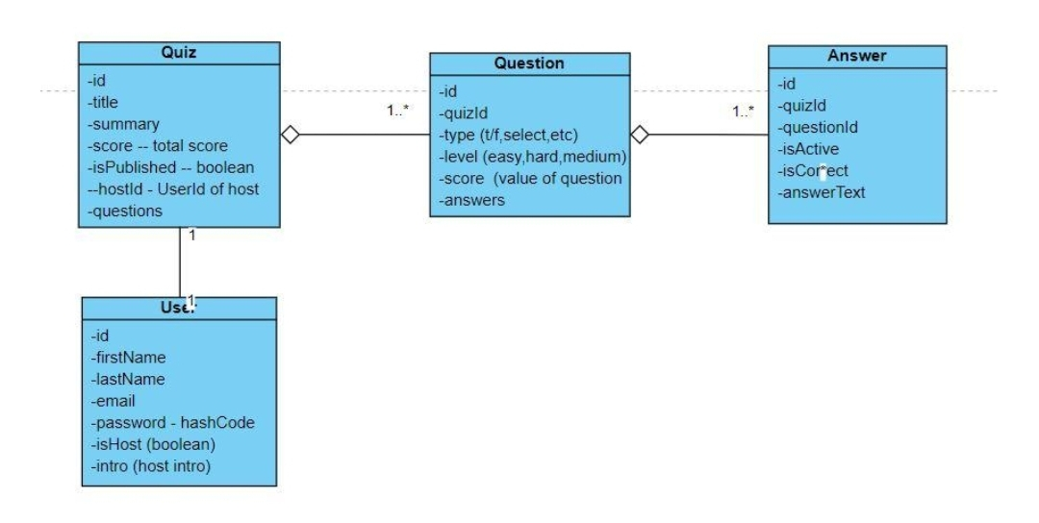

**Fig:** Class Diagram

**4. Testing:**

* 1. **White Box Testing:**

White box testing is defined as the testing of software solution'sinternal structure, design, and coding. In this type of testing, the code is visible to the tester. It focuses primarily on verifying the flow of inputs and outputs through the application, improving design and usability, strengthening security. White box testing is also called Clear testing, Open Box Testing, Structural testing,Transparent Testing, Code-Based Testing and Glass Box Testing.

**Test Case of White Box Testing**

**Test Case Name:** Registration

**Input:** Enter name, dob, mail-id, mobile number.

**Outcomes:** Successfully register.

**Expected Outcomes:** Successfully register.

**Result:** Pass.

* 1. **Black box Testing:**

Black box testing is also known as Behavioral Testing, is a software testing method in which the internal structure/design/implementation of the item being tested is not known to the tester. These tests can be functional or non-functional, through usually functional.

This method is named so because the software program, in the eyes of the tester, is like a black box; inside which one cannot see.

**Test case of Black Box Testing**

**Test Case Name:** Registration.

**Input:** Enter required details for registration.

**Outcomes:** Registered successfully.

**Expected Outcomes:** Registered successfully.

**Result:** Pass.

* 1. **Unit Testing:**

The first test in the development process is the unit test. Unit testing is a level of software testing where individual units or components of a software are tested. The purpose is to validate that each unit of the software performs ass designed. A unit is the smallest testable part of any software. It usually has one or a few inputs ad usually a single output. The source code is normally divided into modules, which in turn are divided into smaller unit called units. These units have specified behaviour. The test done on these units of code is called unit test.

Unit test depends upon the language on which the project is developed. Unit tests ensure that each unique path of the project performs accurately to the documented specifications and contains clearly defined input and expected results. Unit tests are typically written and run by software developers to ensure that code meets its design and behaves as intended.

Here are some of the objectives of unit testing:

* To verify the correctness of code.
* To fix bugs early in the development cycle and save costs.
* To help developers to understand the testing code base and enable them to make changes quickly.
* To help the code reuse.
* To isolate a section of code.
* To test every unction and procedure.
* To learn what functionally is provided by a unit.
* It improves design and allows better refactoring of code and makes the integration simple.
* It helps find problems and resolve them before further testing so they won't impact other bits of code.
* It makes the process of debugging easier.
  1. **Integrated Testing:**

Integration testing is a level of software testing where individual units are combined and tested to verify if they are working properly. Integration testing carries a lot of significance as it helps tester in determining the effectiveness as well as the functionality of the software.

Integration testing is critical to ensure the functional correctness of the integrated system. Integration testing is often the most time consuming and expensive part of testing. Testing performed to expose defects in the interfaces and in the interactions between integrated components or systems.

* 1. **Beta Testing:**

Beta testing is one of the types of user acceptance testing, which adds value to the product as the end user (intended real user) validates the product for functionally, usability, reliability and Compatibility. The main goal of user acceptance testing is to check whether the developed software product fulfil the user requirements.

Beta testing is performed in order to access the product by exposing into real end users. After that the feedback is taken from the users and the defects detected are fixed. Inputs provided by the end users helps in enhancing the quality of the product further and leads to its success. It helps he software product to provide better user experience. This also helps in decision making to invest further in the products or the same product for improvisation. Since Beta Testing happens at the end user's side, it cannot be the controlled activity.

The features of beta testing are as follows:

* Beta testing helps in providing the actual position of the quality. Beta testing generally is done for testing software products like utilities, operating systems and application etc.
* Beta testing focuses on the customers satisfaction.
* It helps to reduce the risk of project failure via user validations.
* Beta testing helps to get direct feedback from users.
* It helps to detect the defect and issues in the system. which is overlooked and undetected by the team of software testers.
* Beta testing helps the user to install. test and send feedback regarding the developed software.

**5. Screenshots**

**Home Page:**

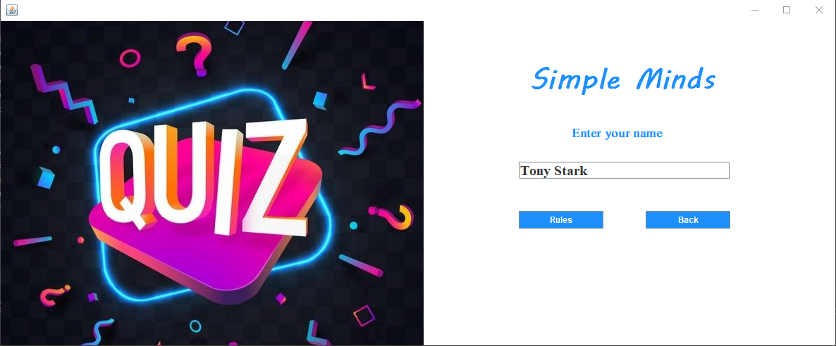

**Rules:**

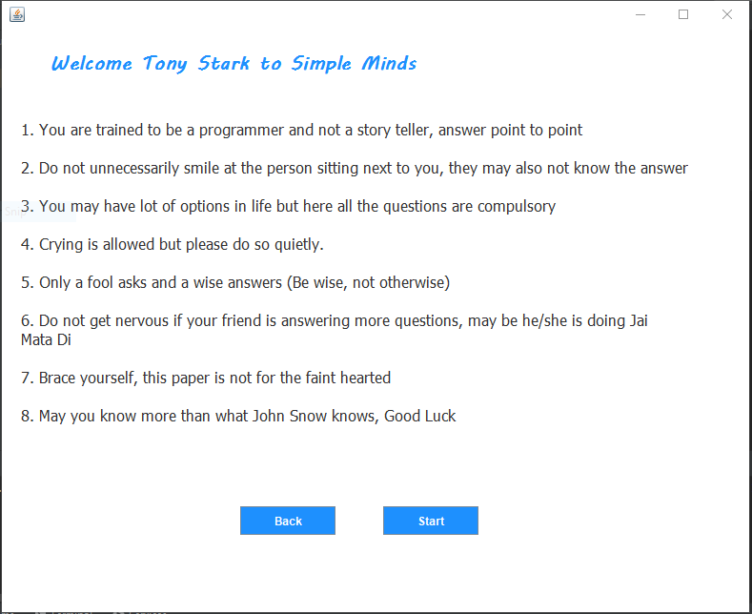

**Questions:**

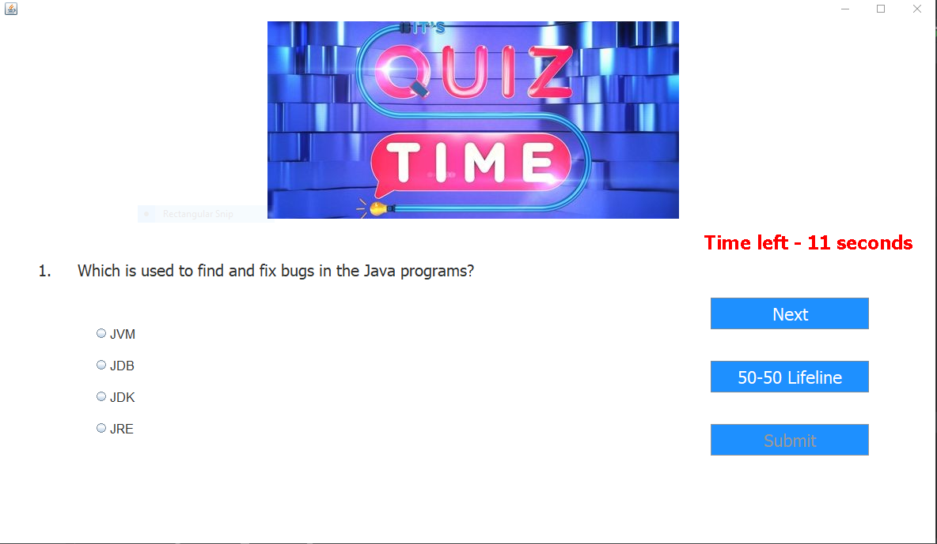

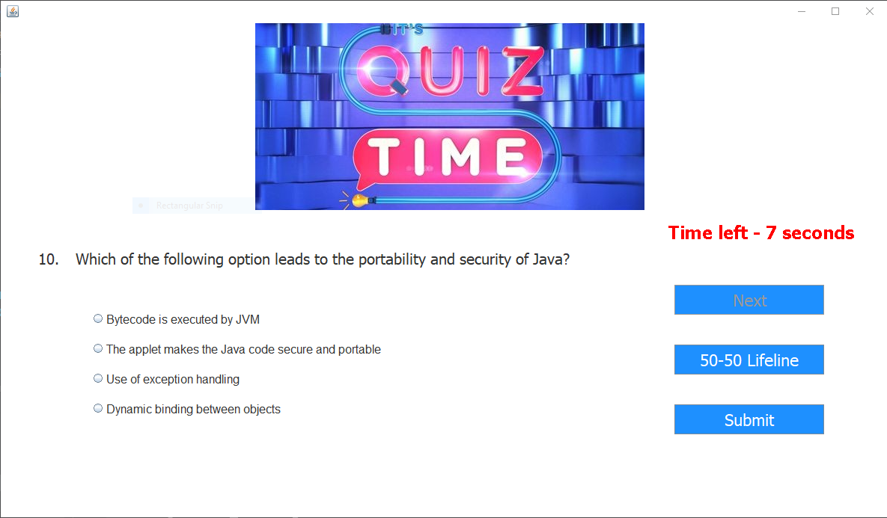

**50-50 Lifeline:**

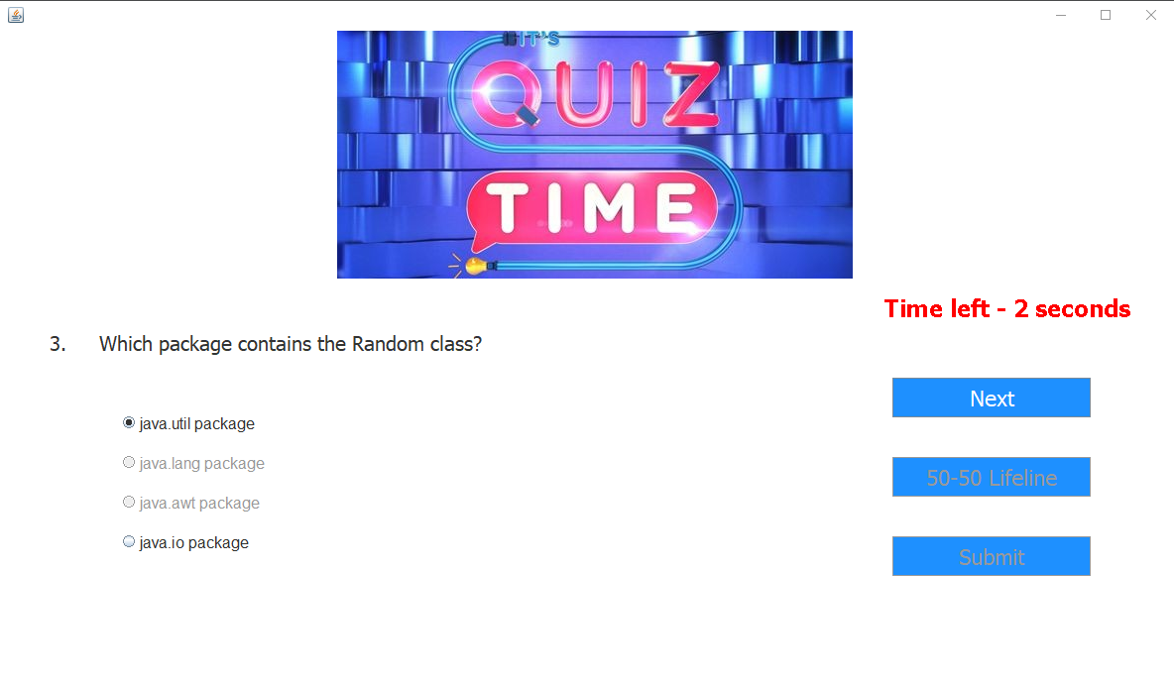

**Score:**

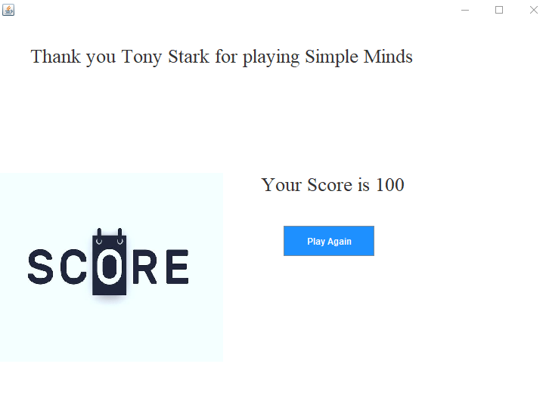

**6. Conclusion**

This online quiz application provides facility to play quiz anywhere and anytime. It save time since user does need to wait for result. So student/user cannot wait for the result. All Student/ user get extra knowledge and skills. Administrator has a privilege to put as much as question n any category given in application. User can register, log-in, and give the test with his/her specific id, and can see the results as well.

**7. Reference:**

https://en.wikipedia.org/

https://www.javatpoint.com/

https://www.w3schools.com/

https://www.tutorialspoint.com/

1. Introduction
2. The project: "Quiz Application' is a collection of number of different types of quizzes like technical, games, sports, etc. A user can access/play the entire quiz and can attempt any of the one. There will be limited number of questions and for each correct answer user will get a credit score. User can see answers as well as can ask a query related to it. There are many quiz applications available currently on internet. But there are few which provide better understanding between users and the application like, providing proper answers, user query Solving, uploading user questions as well as answer to it, etc. To develop a user friendly quiz application which will contain: Numbers of quiz. Answers to every question, Query solving regarding any question, Uploading of user question and answer, and to improve the knowledge level of users. To develop an application which will contain solution to the above problems. By this application the user will come to know about his/her level and can learn additional knowledge. Also by this application a user can expand his/her knowledge among the world.
3. Aim:
4. Our aim is to develop an application for the users in which a user can attempt any number of quizzes related to his/her choice.
5. Objective:
6. The main objective of "Quiz Application is to facilitate a user friendly environment for all users and reduces the manual effort. In past days quiz is conducted manually but in further resolution of the technology we ae able to generate the score and pose the queries automatically. The functional requirements include creating users that are going to participate in the quiz, automatic score and report generation and administrative tasks like add, delete. update for admin privilege users. In this application. all the permissions lies with the administrator i.e. specifying the details of the quiz with checking result will show to interviewee or not. addition of question and answers. marks for each question. Set timer for each quiz and generate report with score for each
7. quiz.
8. Purpose:
9. This web application provides facility to Play online quiz and practice Grammar, Aptitude, and G.K. It provides a good platform, where a student not only judges there knowledge/skill but also they can improve knowledge/skill at the same time
10. Scope:
11. The Scope of this project is very broad in terms of gaining knowledge and sharing knowledge among world.
12. Few points are:
13. [ ] Can be used anywhere any time as it is a web based application.
14. [ ] This application will be used in educational institutions as well as in corporate world.
15. Applicability:
16. Anyone. whether a newcomer or professional, willing to learn they can choose it All users will have access to all subject containing sub topics, users will receive best experience without any interruptions.
17. Description:
18. Firstly, we have to make interfaces for Home Page Login Page, Questions Attempting forum, Result Page, & Profile of user. Currently, there are websites which only provide limited number of quizzes related to different domain. Many websites do not have a single platform for quizzes related to technical, G.K Aptitude. Games. etc. And there is not a website where the users can upload his/her questions and answers to the others. We have to develop an application which can resolve all of the above problems. By this user can gain knowledge, can solve his/her query and spread his/her knowledge among the World.
19. Problem Definition:
20. Quiz Contest is an application developed to conduct a quiz based on time constraints. Quiz Contest system is accessed by entering the user name. Before start of the quiz, the rules and regulations are displayed that includes description of the time limit, number of questions to be answered and scoring methods. Quiz is started by displaying one question with four options each based on computer and general knowledge. if the answer correct, 10 score is incremented and no negative marks for wrong answers. If the time exceeds 15secs next question will come automatically after giving few limited question's answer quiz application will finally direct you to the score page. Final score will be displayed.
21. Hardware Requirement:
22. Most current Computers and Laptop have enough specifications to be used to create an Application. The most important specification to check on the computer would be the size of the RAM, which should be over 2 GB, more is better. This will ensure that the computer runs quickly and smoothly, even with heavier programs. The computer should have a keyboard and mouse attached and working as well.
23. ***Table***
24. Software Requirement:
25. Aside from a Computer and internet connection, most of the tools you need to build an Application are Software Program. Some of which may already be on your computer.
26. ***Table***
27. Technology Used:
28. Java:
29. Java is an object-oriented programming language that produces software for multiple platforms. When a programmer writes a Java application, the compiled code (known as bytecode) runs on most operating systems (OS), including Windows, Linux and Mac OS.
30. Java Swing:
31. Swing is a GUI widget toolkit for Java. It is part of Oracle’s Java Foundation Classes – an API for providing a graphical user interface for Java programs. Swing was developed to provide a more sophisticated set of GUI components than the earlier Abstract Window Toolkit.
32. Java AWT:
33. The Abstract Window Toolkit (AWT) is Java's original platform-dependent windowing, graphics, and user-interface widget toolkit, preceding Swing. The AWT is part of the Java Foundation Classes (JFC) — the standard API for providing a graphical user interface (GUI) for a Java program.
34. Testing:
35. White Box Testing:
36. White box testing is defined as the testing of software solution's
37. internal structure, design, and coding. In this type of testing, the code is visible to the tester. It focuses primarily on verifying the flow of inputs and outputs through the application, improving design and usability, strengthening security. White box testing is also called Clear testing, Open Box Testing, Structural testing,
38. Transparent Testing, Code-Based Testing and Glass Box Testing.
39. Test Case of White Box Testing
40. Test Case Name: Registration
41. Input: Enter name, dob, mail-id, mobile number.
42. Outcomes: Successfully register.
43. Expected Outcomes: Successfully register.
44. Result: Pass.
45. Black box Testing:
46. Black box testing is also known as Behavioral Testing, is a software testing method in which the internal structure/design/implenmentation of the item being tested is not known to the tester. These tests can be functional or non-functional, through usually functional.
47. This method is named so because the software program, in the eyes of the tester, is like a black box; inside which one cannot see.
48. Test case of Black Box Testing
49. Test Case Name: Registration.
50. Input: Enter required details for registration.
51. Outcomes: Registered successfully.
52. Expected Outcomes: Registered successfully.
53. Result: Pass.
54. Unit Testing:
55. The first test in the development process is the unit test. Unit testing is a level of software testing where individual units or components of a software are tested. The purpose is to validate that each unit of the software performs ass designed. A unit is the smallest testable part of any software. It usually has one or a few inputs ad usually a single output. The source code is normally divided into modules, which in turn are divided into smaller unit called units. These units have specified behaviour The test done on these units of code is called unit test.
56. Unit test depends upon the language on which the project is developed. Unit tests ensure that each unique path of the project performs accurately to the documented specifications and contains clearly defined input and expected results. Unit tests are typically written and run by software developers to ensure that code meets its design and behaves as intended.
57. Here are some of the objectives of unit testing:
58. [ ] To verify the correctness of code.
59. [ ] To fix bugs early in the development cycle and save costs.
60. [ ] To help developers to understand the testing code base and enable them to make changes quickly.
61. [ ] To help the code reuse.
62. [ ] To isolate a section of code.
63. [ ] To test every unction and procedure.
64. [ ] To learn what functionally is provided by a unit.
65. [ ] It improves design and allows better refactoring of code and makes the integration simple.
66. [ ] It helps find problems and resolve them before further testing so they won't impact other bits of code.
67. [ ] It makes the process of debugging easier.
68. Integrated Testing:
69. Integration testing is a level of software testing where individual units are combined and tested to verify if they are working properly. Integration testing carries a lot of significance as it helps tester in determining the effectiveness as well as the functionality of he software.
70. Integration testing is critical to ensure the functional correctness of the integrated system. Integration testing is often the most time consuming and expensive part of testing. Testing performed to expose defects in the interfaces and in the interactions between integrated components or systems.
71. Beta Testing:
72. Beta testing is one of the types of user acceptance testing, which adds value to the product as the end user (intended real user) validates the product for functionally, usability, reliability and Compatibility. The main goal of user acceptance testing is to check whether the developed software product fulfil the user requirements.
73. Beta testing is performed in order to access the product by exposing into real end users. After that the feedback is taken from the users and the defects detected are fixed. Inputs provided by the end users helps in enhancing the quality of the product further and leads to its success. It helps he software product to provide better user experience. This also helps in decision making to invest further in the products or the same product for improvisation. Since Beta Testing happens at the end user's side, it cannot be the controlled activity.
74. The features of beta testing are as follows:
75. [ ] Beta testing helps in providing the actual position of the quality. Beta testing generally is done for testing software products like utilities, operating systems and application etc.
76. [ ] Beta testing focuses on the customers satisfaction.
77. [ ] It helps to reduce the risk of project failure via user validations.
78. [ ] Beta testing helps to get direct feedback from users.
79. [ ] It helps to detect the defect and issues in the system. which is overlooked and undetected by the team of software testers.
80. [ ] Beta testing helps the user to install. test and send feedback regarding the developed software.
81. CONCLUSION
82. This online quiz application provides facility to play quiz anywhere and anytime. It save time since user does need to wait for result. So student/user cannot wait for the result. All Student/ user get extra knowledge and skills. Administrator has a privilege to put as much as question n any category given in application. User can register, log-in, and give the test with his/her specific id, and can see the results as well.
83. Reference:
84. https://en.wikipedia.org/
85. https://www.javatpoint.com/
86. https://www.w3schools.com/
87. https://www.tutorialspoint.com/The project: “Quiz Application” is a collection of number of different types of quizzes like
88. technical, games, sports, etc. A user can access/play the entire quiz and can attempt any of the
89. one. There will be limited number of questions and for each correct answer user will get a credit
90. score. User can see answers as well as can ask a query related to it. There are many quiz
91. applications available currently on internet. But there are few which provide better understanding
92. between users and the application like, providing proper answers, user query Solving, uploading
93. user questions as well as answer to it, etc. To develop a user friendly quiz application.
94. which will contain : Numbers of quiz, Answers to every question, Query solving regarding any
95. question, Uploading of user question and answer, and to improve the knowledge level of users.
96. To develop an application which will contain solution to the above problems. By this application
97. the user will come to know about his/her level and can learn additional knowledge. Also by this
98. application a user can expand his/her knowledge among the world.
99. The project: “Quiz Application” is a collection of number of different types of quizzes like
100. technical, games, sports, etc. A user can access/play the entire quiz and can attempt any of the
101. one. There will be limited number of questions and for each correct answer user will get a credit
102. score. User can see answers as well as can ask a query related to it. There are many quiz
103. applications available currently on internet. But there are few which provide better understanding
104. between users and the application like, providing proper answers, user query Solving, uploading
105. user questions as well as answer to it, etc. To develop a user friendly quiz application.
106. which will contain : Numbers of quiz, Answers to every question, Query solving regarding any
107. question, Uploading of user question and answer, and to improve the knowledge level of users.
108. To develop an application which will contain solution to the above problems. By this application
109. the user will come to know about his/her level and can learn additional knowledge. Also by this
110. application a user can expand his/her knowledge among the world